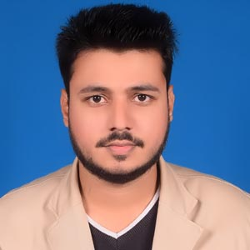
RESUME OF
Md. Younus Ali
MAILING ADDRESS:
Village: Shaheb Para (Muktijoddha Road), Post Office: Saidpur-5310,
Upazilla: Saidpur, District: Nilphamari
Mobile: +8801821242710
E-mail: myounus095@gmail.com

CAREER OBJECTIVES
To build up a highly professional skill, working with a renowned organization and tie up own knowledge, experience, and the employer’s expectations in order to meet the organization’s mission and vision and to prove myself to be an important asset for that organization through my dedication, sincerity, and highest level of professionalism.
PERSONAL INFORMATION
Father's Name | : | Md. Kalam
Mother's Name | : | Nazma khatun
Permanent Address | : | Village: Shaheb Para (Muktijoddha Road), Post Office: Saidpur-5310, Upazilla: Saidpur, District: Nilphamari
Present Address | : | Village: Shaheb Para (Muktijoddha Road), Post Office: Saidpur-5310, Upazilla: Saidpur, District: Nilphamari
Date of Birth | : | 13-11-1994
Gender | : | Male
Marital Status | : | Unmarried
Height | : | 6 feet 1 inch.
Weight | : | 76
Nationality | : | Bangladeshi
Religion | : | Islam
Blood group | : | AB(+)
Home District | : | Nilphamari

EDUCATIONAL QUALIFICATIONS
Name of Degree | Concentration | Name of Institutions/  University | Passing  Year | Board/ University | Result  CGPA/GPA
SSC | Humanities | Bangladesh Railway Govt. High School, Saidpur, Nilphamari | 2009 | Rajshahi | 3.13  (Out of 5.00)
HSC | Business Studies | Mokbul Hossain Technical and Business Management College, Saidpur, Nilphamari | 2011 | Technical | 4.23  (Out of 5.00)
BBS (Pass) | Business Studies | Saidpur College, Saidpur, Nilphamari | 2015 | National University | 2nd Division
MBS(preliminary to masters) | Management | Carmichael College, Rangpur |  | National University | Final year (Running)
Experience
- Banglalink : Working as a SSE, since December 2017 to March 2020.

EXTRA CURRICULAR ACTIVITIES
- Scouting Since March 2005 to till now
- Rover Scout
- Adult Leader
LANGUAGE EFFICIENCY
- Bengali : Mother Tongue
- English : Reading, Writing, Listening, and Speaking Fluently
COMPUTER LITERACY
- MS Office Package : Word, Excel, Access, and Power Point
- Internet : Access E-mail, Browsing Frequently, Data scraping, Lead Generate.
MY TRAILS
- Good time management.
- Good communication Skills.
- Can Work under pressure.
- Work effectively both in individual & group works.
- Ability to take challenges.
- Good presentation skill.

DECLARATION
I hereby, declare that the statements made by me in the curriculum vitae are true, complete and correct to the best of my knowledge and behalf.

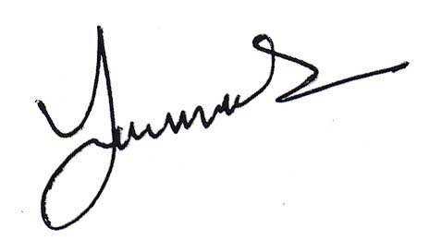

Date: 20-05-2021 _______________________
(Signature)

